M01039503 – Hiren Mario Fernando
EX1:
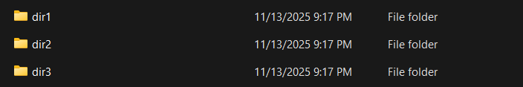

EX 2:
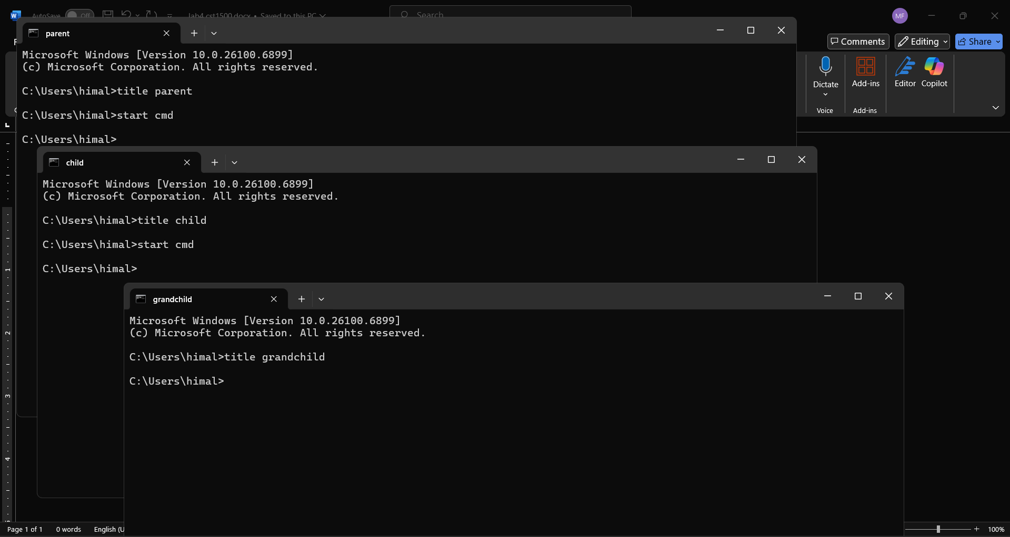
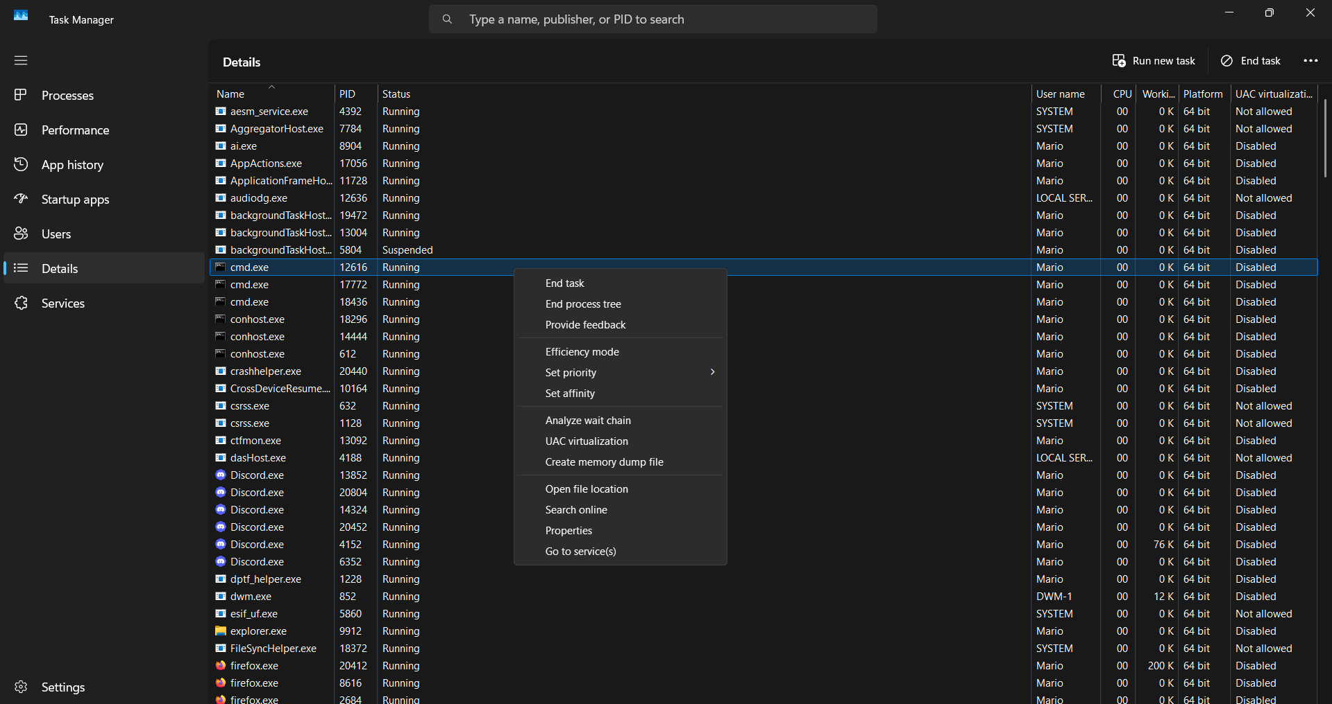

EX3)
%%i holds inputs like ‘rock, paper, scissors’.
%%n holds numerical values like 10,20,30.
%%c handles the current input statement.

EX4:
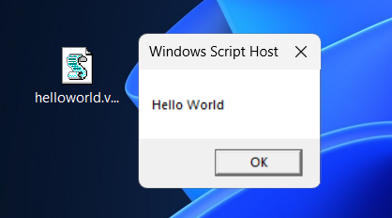

EX5:
- Double clicking on icon in explorer ran the command as so: 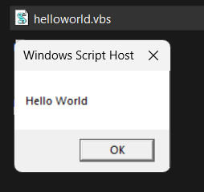
- ..
CLI interface’s advantage over GUI is that it doesn’t need to render anything visually where GUI has popups etc, hence CLI uses lesser system resources.

EX6:
Processor.vbs =
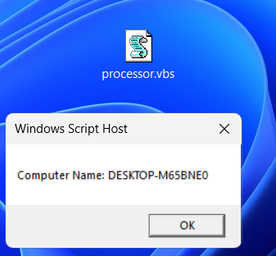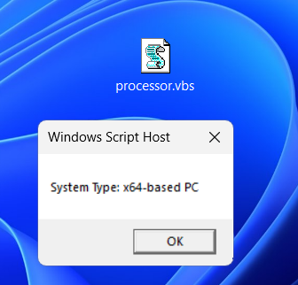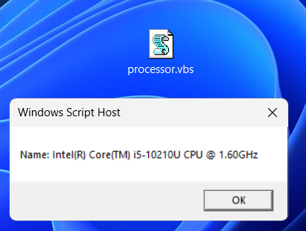
Keyboard.vbs =
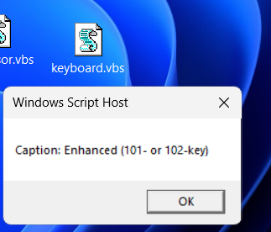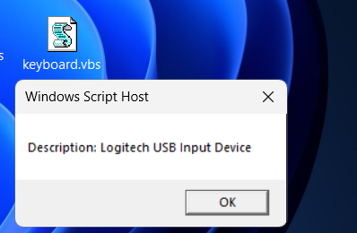
EX 8:
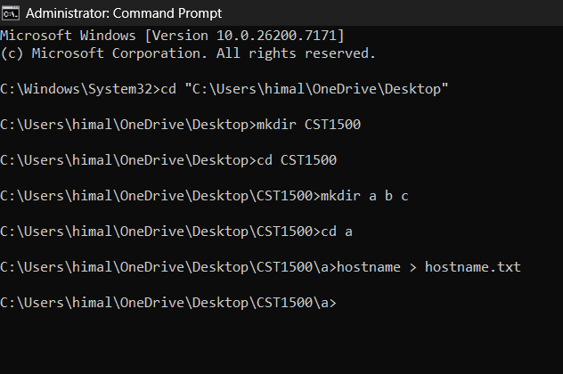
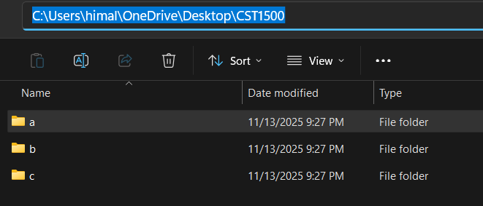
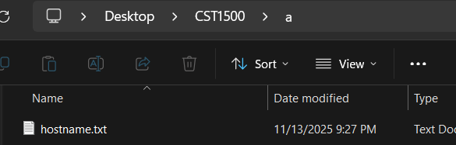
EX 9:
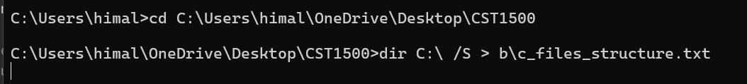
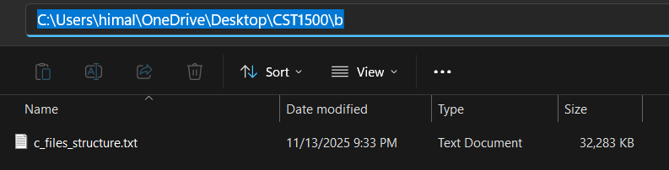

EX10:
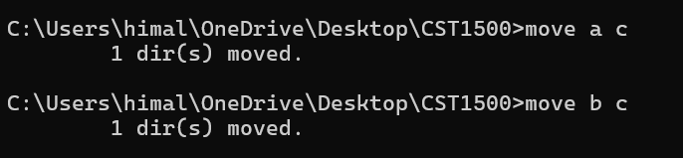
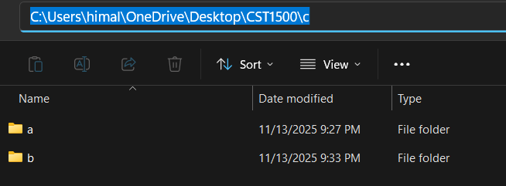
EX 11:
- What is the purpose of the Path command?
Path commands let us know the current path we are executing commands to.

